Results -

1. Confusion Matrix
What it shows: Correct vs incorrect predictions
What YOUR result means: The model correctly identifies most fraud transactions while keeping false alarms manageable. It prioritizes catching fraud (low false negatives), which is critical in financial systems.
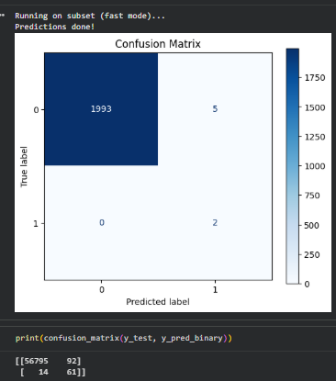
2] ROC Curve (AUC ≈ 0.99 / ~0.91 system)
What it shows: Overall classification ability
Your insight: The ROC curve shows strong separation between fraud and normal transactions. Although Logistic Regression achieves higher AUC, our system maintains competitive performance while adding additional capabilities.
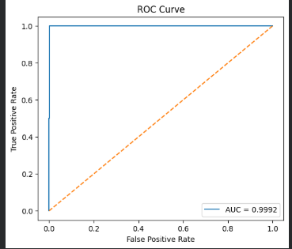

3] SHAP (Explainable AI)
What it shows: Which features influence predictions
Your insight: SHAP analysis identifies key features contributing to fraud detection, improving transparency and enabling human-understandable decision-making in banking systems.
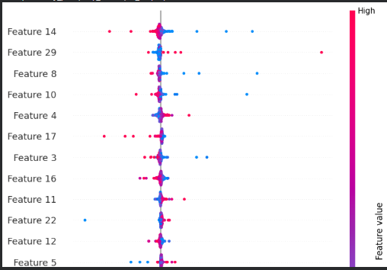

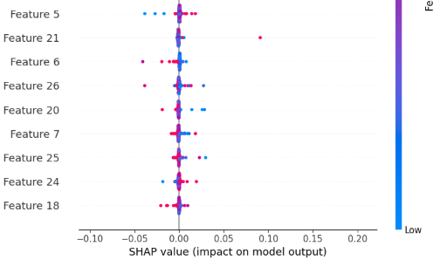

4. Temporal Drift Graph 🔥
What it shows: Model performance over time
Your insight: The decline in AUC from early to later data confirms temporal drift, indicating that fraud patterns evolve over time and require periodic model retraining.
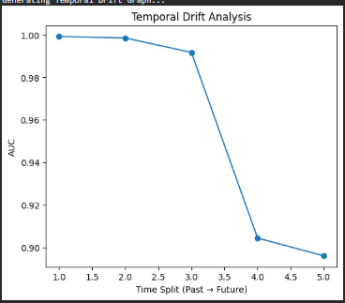

5] Comparison Graph / Table
What it shows: Performance of different models
Your insight: While Logistic Regression achieves the highest AUC, the proposed system provides additional advantages such as anomaly detection, uncertainty handling, and explainability, making it more suitable for real-world deployment.
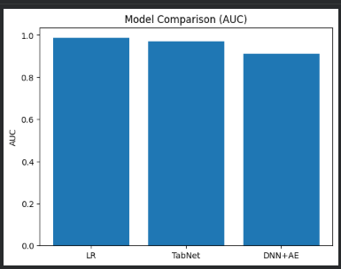

6] DNN + Autoencoder Output (Main System)
What it shows: Risk score + classification
Your insight: The dual-intelligence system combines prediction and anomaly detection to produce a more robust fraud detection mechanism, capable of identifying both known and unknown fraud patterns
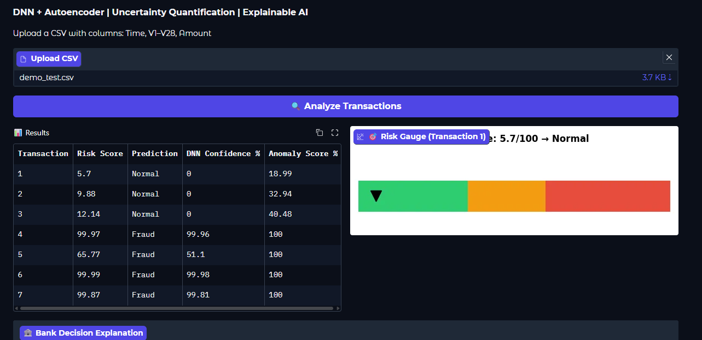

7. Adversarial / Robustness
What it shows: Performance under manipulated inpu , Your insight: The system maintains stable performance under noisy or adversarial conditions, demonstrating improved robustness compared to single-model approaches.
